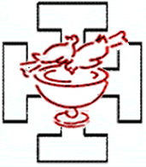

THE WORLD COMMUNITY FOR CHRISTIAN MEDITATION (WCCM)
Members of the International Oblate Council

Prior  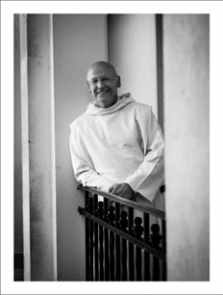 | Laurence Freeman OSB  is a Benedictine monk and Director of the WCCM and of its international centre at Bonnevaux where he now resides. Of English and Irish parentage he studied English Literature at Oxford University. Before entering monastic life, in which his teacher was John Main, he worked with the UN in New York, in banking and  journalism. He is a monk of the Monastery of Sta Maria di Pilastrello, Lendinara, in the Benedictine Congregation of Monte Oliveto. He is the author of many books, including Jesus the Teacher Within, Selfless Self, Beauty's Field and, most recently, Good Work. He is Prior of the WCCM Benedictine Oblate Community.
Eileen Dutt – International Oblate Coordinator (IOC)
National Oblate Coordinator (NOC) UK 2007-18 and IOC from 2012 to date. A member of the International Planning Team for 2013 & 17 Benedictine Oblate Congress in Rome. Left her management job in the City of London to take up a position as Pastoral Assistant for her local parish. She has a Certificate in Benedictine Leadership and Diploma in Pastoral Ministry. Spent time as Chair of a Homeless Sanctuary and an active member of CAMID - raising awareness of the needs of persons living with disabilities and addictions. For a time WCCM representative on UKOT (UK Oblate Team) – aim is to strengthen links between Benedictine Oblates attached to different monasteries.
'God doesn't always call those qualified for the task he qualifies those he calls' 1Cor 1:27-29.

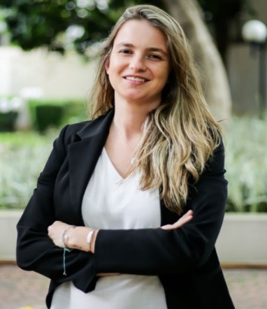 | Tayna Malaspina - Brazil  Graduated in Social Communication, with a Masters in Social Psychology. Started meditating through Buddhism, despite being from a Catholic family. When she discovered Christian meditation, she had the feeling of "coming home". Since then, she seeks to share this gift with the world. In Brazil, she started the project "Brincando de Meditar", which aims to develop the contemplative dimension in children. She was coordinator of the community in the state of São Paulo. She is coordinator of the Oblates in Brazil and coordinator of the Young Adult program of WCCM.
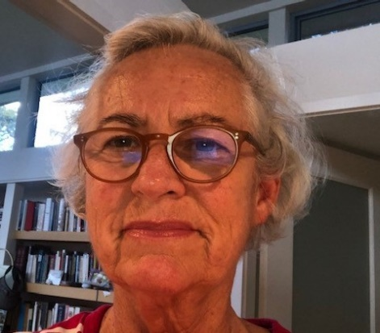 | Judi Taylor - Australia  Like my mother before me, I am drawn to places of deep quiet, of prayer, and feel at home there where love and care have accumulated over time. I’ve been most blessed to be part of the Sydney oblate cell for many years, Trish Panton was so committed to our formation in the precepts, her presence continues strongly with us. I love having the Rule of Benedict inform my life, it’s balance and sanity is a wonderful guide. The richness of life in the meditation Community is a grace and a gift, we are so blessed.
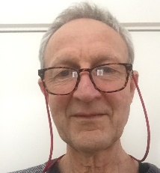 | Paul Taylor - Australia  I have been a meditator for over 40 years and for the last 25 years I have been practicing Christian Meditation under the wise guidance of Fr. Laurence and Fr. John. and others as part of the WCCM.  Judi and I took our first steps toward becoming Oblates around 2003 and took our final Oblation at Monte Olivetti in 2009. We have been active members of the Sydney Cell group ever since.  I have mentored several people over the years on their journeys to full Oblation.  Judi and I have also been very involved in the teaching of meditation and organising retreats for a Community of marginalised people called DAVID’S PLACE.  We live on an island about one hours drive north of Sydney and this place allows us to organise contemplative retreats for various groups including our Oblate Cell group and people from DAVID’S PLACE.  For the last 10 years we have also been leading an Inter Faith group that meets once a month to meditate together and to discuss readings from the World’s great religious traditions.  We both feel very honoured to be part the Oblate Council and all its activities.
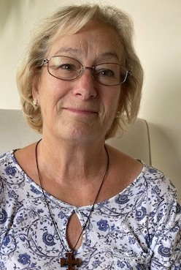 | Janet Robbins – Member UK Oblate Council (UKOC)  Janet has been a meditator for 20 years and became an oblate in the same year that she was appointed UK National Coordinator in 2011. She now support those in Formation in the UK, guiding mentors and member of the UK Oblate Council. She regularly leads retreats in Europe. Like all members of our Community, Janet recognises she is a beginner and has been a beginner for all of the 20 years she has been meditating. Each day, twice daily, she says, “I turn up to meditate and each day I begin again. There are no experts or masters. It is good to know that”!
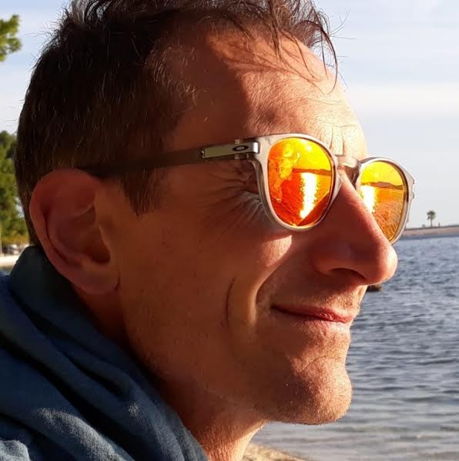 | Stefan Reynolds – National Oblate Coordinator (NOC) Ireland  Stefan Reynolds – National Oblate Coordinator (NOC) Ireland  Stefan Reynolds became an Oblate in 1995. Helived for some years in the Christian Meditation Centres in  London and has a Doctorate from the University of London in Christian Spirituality. Currently he works at the Cistercian monastery of Mount Melleray Abbey in Waterford, IReland, the area of hospitality. He gives regular retreats on Christian mysticism, paints Icons and he is also author several books, the last one being, ‘The Wisdom of Love  in the Song of Songs'. He is Oblate Co-Ordinator for the Ireland and Editor of Via Vitae, the Oblate Newsletter.

